AUTHOR REQUESTED PRESENTATION FROM THE AUTHOR

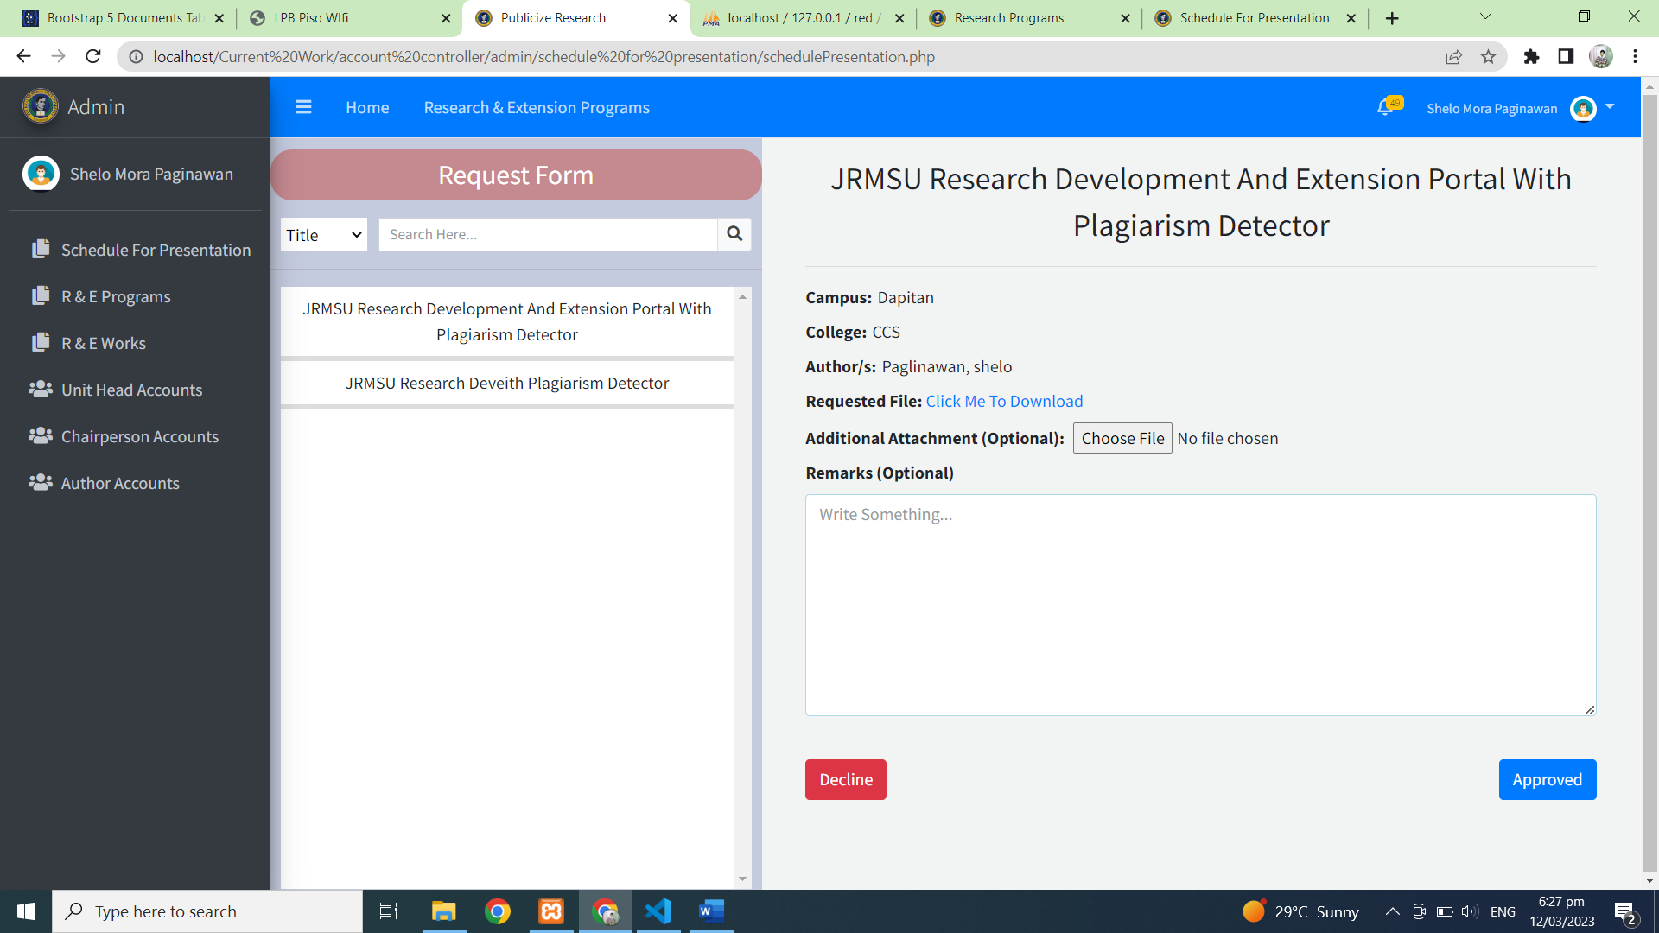

LIST OF COMPLETED RESEARCH OR EXTENSION PROGRAMS

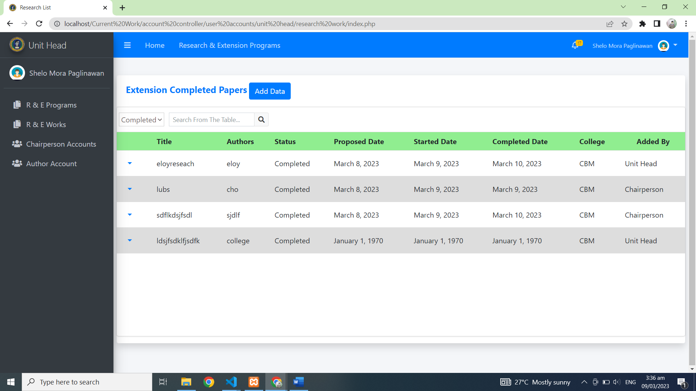

REQUESTED SCHEDULE PRESENTATION FROM THE AUTHOR

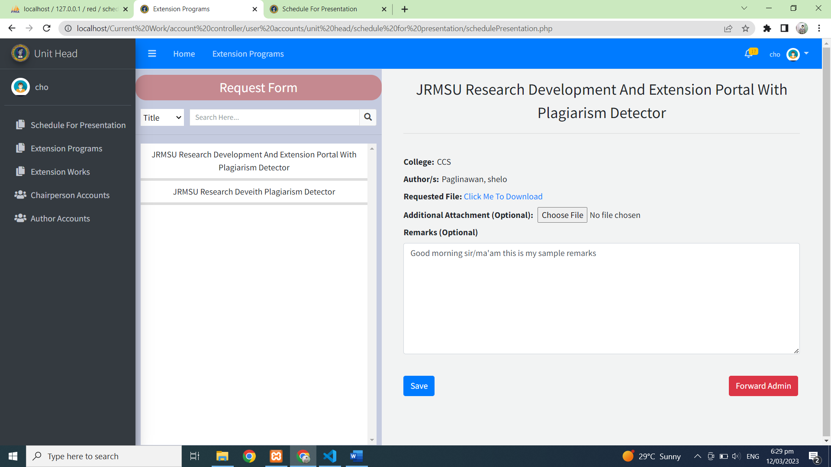

REQUESTED SCHEDULE PRESENTATION FROM THE AUTHOR

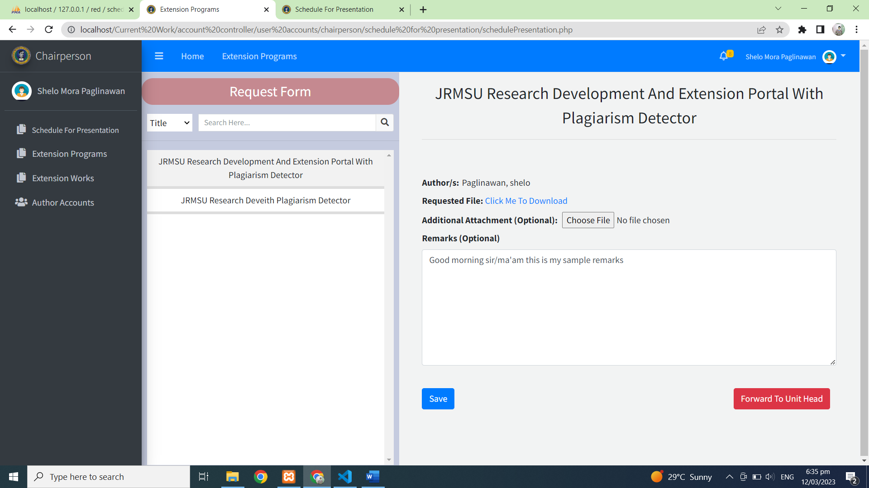

REQUEST SCHEDULE FOR PRESENTATION

